**Capstone Project - The Battle of Neighborhoods**

**Introducting new bicycle parking locations**

**Content**

1 Introduction Section :

1.1 Discussion and background

1.2 Problem to be resolved

1.3 Targeted audience

2 Data Section:

2.1 Required data

2.2 Data sources

3 Methodology:

3.1 Analysis

3.2 Clustering

4 Disscussion

5. Results

6 Conclusion

**1 Introduction Section :**

[1] Düsseldorf is a city on the River Rhine in western Germany and is the capital city of the state of North Rhine-Westphalia. It is one of the economic centers of the country, and a major city within the Rhine-Ruhr metropolitan area, with a population of almost 600,000.The capital of North Rhine-Westphalia Germany, Dusseldorf is a regional economic powerhouse straddling the banks of the Rhine River. Altstadt is Dusseldorf's lovely old town.

**1.1 Discussion and background**

[2] Düsseldorf is connected to some national and international cycling paths, including EV15 The Rhine Cycle Route. The city of Düsseldorf is a member of the German North Rhine-Westphalia District, Municipality and City Friends of Pedestrians and Cyclists Working Group, who bestowed upon Düsseldorf the title of "Friend of Cyclists City" in 2007, although the city still has a few gaps in the network of cycle paths in the eyes of many of its citizens.

**1.2 Problem to be resolved**

City have some official bicycle parking spots but most all of them are located on railway station. Can we endorse a location in Duesseldorf to open a new bicycle parking?. New bicycle parking spot will motivate people to go shopping or hangout on bicycles which can reduce the traffic and car parking problem in the city.

**1.3 Targeted audience**

The report is aimed primarily at those involved in city planning, sports clubs and students learning data science.

**2 Data Section:**

**2.1 Required data**

We are going to predict a new bicycle parking location, so a list of existing bicycle location will a perfect point to start. We will need a list of coordinates where currently existing parking are located. For the sake of simplicity we will ignore the number of parking spaces assigned to each bicycle parking place. Also we will only consider bicycle parking which are official assigned from the city. A list of all the zip codes in the city which will be use to gather and cluster the bicycle frendly businesses from each neighbourhood. The other list we need is the number and type of businesses and avenue located around these existing parking places. Average distance of bicycle parking from avenues can be calculated later.

**2.2 Data sources**

A variety of publicly open data about the city of Duesseldorf is available on the city website. We will be using <https://opendata.duesseldorf.de/node/40945/download>, where a list of all bicycle parking locations with latitudes and longitudes are available as csv file. This data is maintained by the city itself

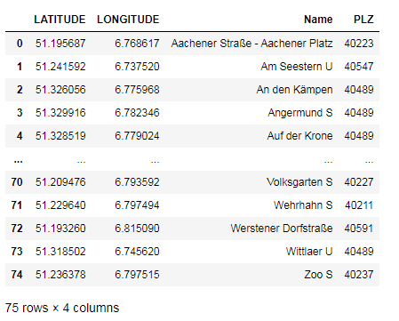

from the record we can see there are 75 official bicycle parkings in the city.

We can get a json file about geo data from the following link. This geojson will be use to locate draw the boundries of around every district and give district every district a u '<https://opendata.duesseldorf.de/node/42155/download'>

**3 Methodology**

In this venture we will coordinate our endeavors on distinguishing territories of Düsseldorf that have bicycle friendy venues, especially those with low number bicycle parking. We will constrain our investigation to territory around any given parking place. In initial step we have gathered the necessary information: area and type of each existing parking inside from Düsseldorf focus bike+ride places. We have additionally distinguished bicycle friendly businesses (as indicated by Foursquare classification). Second step in our investigation will be figuring and investigation of 'bicycle friendly business density' across various territories of Düsseldorf - we will utilize maps to distinguish a couple of promising zones near focus with low number of eateries all in all (and no parking in region) and concentrate on those zones.

**3.1 Analysis**

In order to get the first impression, we will initialize our analysis by plotting the existing bicycle parking places on a map. For this project we are using folium library to plot the parking coordinates on the map.

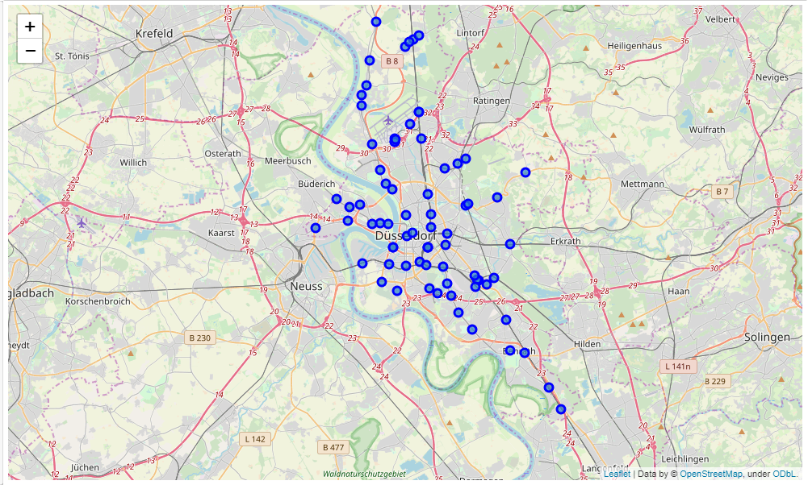

Fig.1 Locations of all bicycle parking stands in the city of Düsseldorf

Next, we are going to start utilizing the Foursquare API to explore the neighborhoods and segment them. Define Foursquare Credentials and Version. Table below shows how many venues were returned for each parking spot.

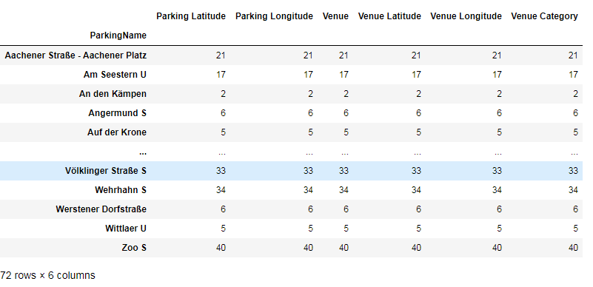

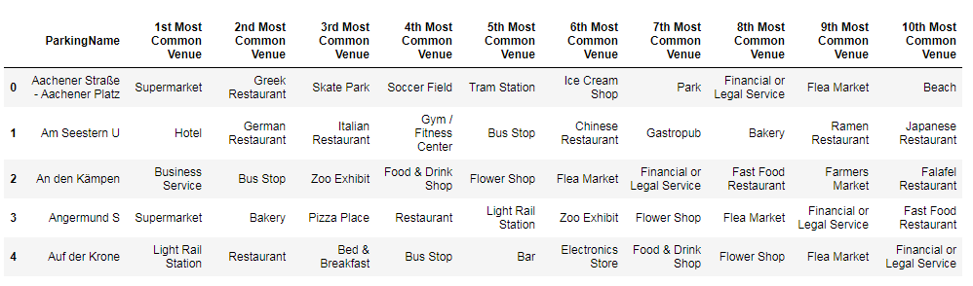

**3.2 Clustering**[**¶**](http://localhost:8888/notebooks/Documents/Capstone%20-%20The%20Battle%20of%20Neighborhoods%20(week2).ipynb#3.2-Clustering)

Run k-means to cluster the parkings into 5 clusters.

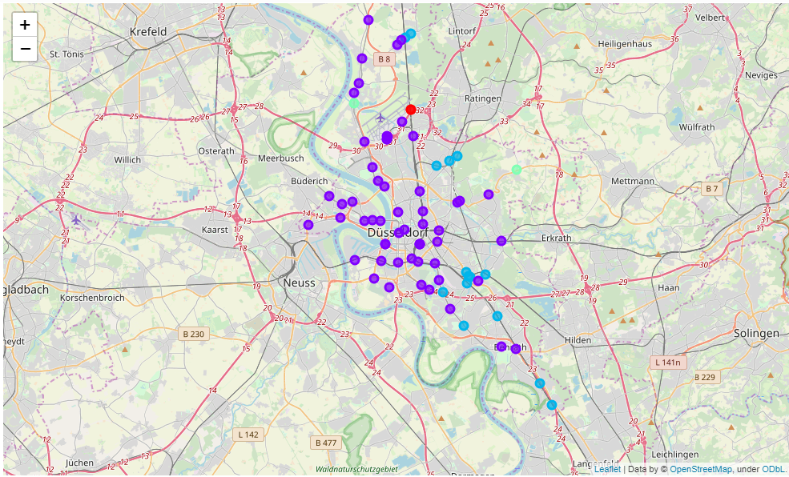

We are considering the most bicycle friendly areas where venues like supermarket, bakery, playground etc. are located. Most bicycle friendly cluster is shown in the table below.

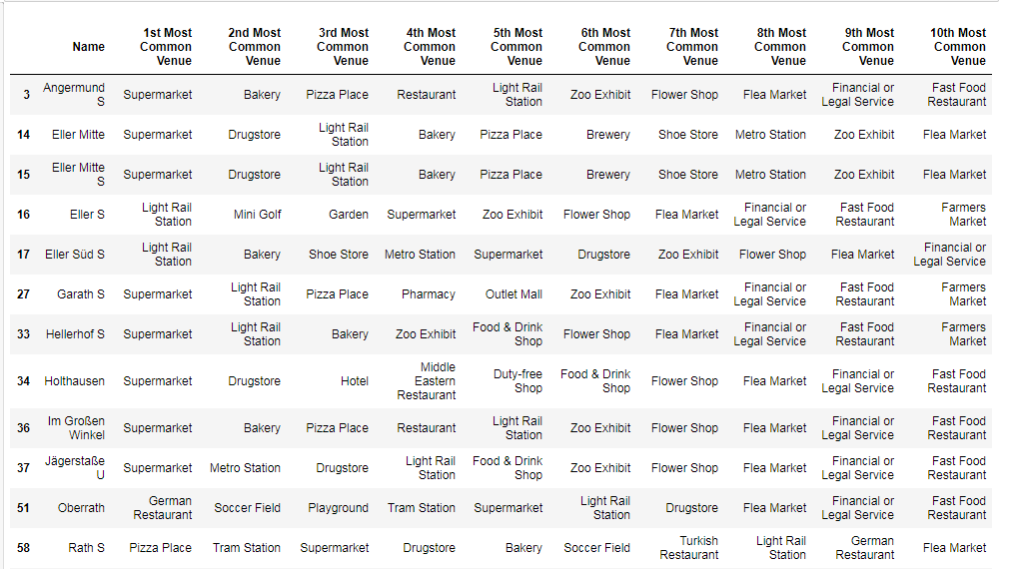

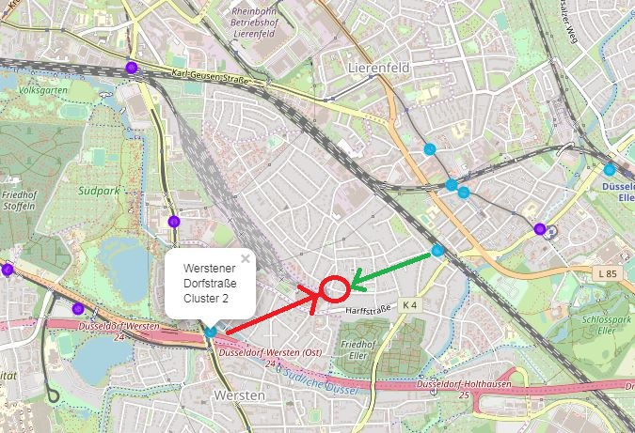

**4. Discussion**

Our investigation shows that in spite of the fact that there is an incredible number of bicycle parking in Düsseldorf, there are pockets of low parking thickness genuinely near downtown area (Werstener Dorfstrasse). Most noteworthy centralization of parkings was distinguished north and west from the city

5. Results

As shown in the figure above a new bike parking station between ‘Werstener Dorfstrasse’ and ‘Eller Süd’ may provide an efficient bicycle parking place for the for the riders. This new parking place will tightly couple the bicycle friendly parking cluster (cluster 2).

6 Conclusion

In this report for the sake of simplicity and learning we have taken a very simple approach to find a new location for the parking. For further optimization we can consider the distance between city center and the parking spaces and add it to our dataset to have a even better clustering.

Further more boundaries of the city districts can be user in relation to bicycle friendly areas to create a heat map of the city. Such a heat map can provide a better understanding of the unfilled gaps of parking between different districts

**references**

1. <https://en.wikipedia.org/wiki/D%C3%BCsseldorf>
2. <https://en.wikivoyage.org/wiki/D%C3%BCsseldorf>